We can train LST using one sentence at a time, but it’s very time consuming, so we will train in batch on sentence, but how we can train in batches.

Lets say batch size is 5, so we will provide as input the first word of each sentence in a batch to LSTM at t=1, then at t=2 we provide second word of each sentence, and t=n we provide nth word of each sentence.

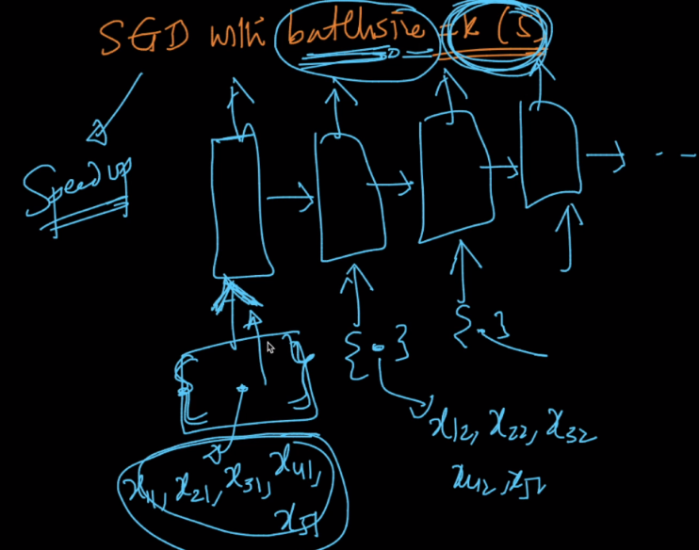

But what if sentences in a batch are of different length, so how it works.

So to make it work we do padding to a fixed size. So if length of sentence is smaller than padding size sentence 0’s will be appended, and if sentence size is greater, no or required characters will be truncated.

